DATA INGESTION

* 1. 1. Create the necessary structure in a MySQL database using the steps mentioned below: a. Create a new database in MySQL with the name midproject
  2. b. Create a table in this database with the name census_adult to store the input dataset

mysql -u edu_labuser -pedureka -h dbserver.edu.cloudlab.com;

use labuser_database;

CREATE TABLE new_census_adult(

age int

,workclass VARCHAR(50)

,fnlwgt int

,education VARCHAR(20)

,education_num int

,marital_status VARCHAR(20)

,occupation VARCHAR(50)

,relationship VARCHAR(50)

,race VARCHAR(50)

,sex VARCHAR(20)

,capital_gain int

,capital_loss int

,hours_per_week int

,native_country VARCHAR(50)

,income VARCHAR(10));

; 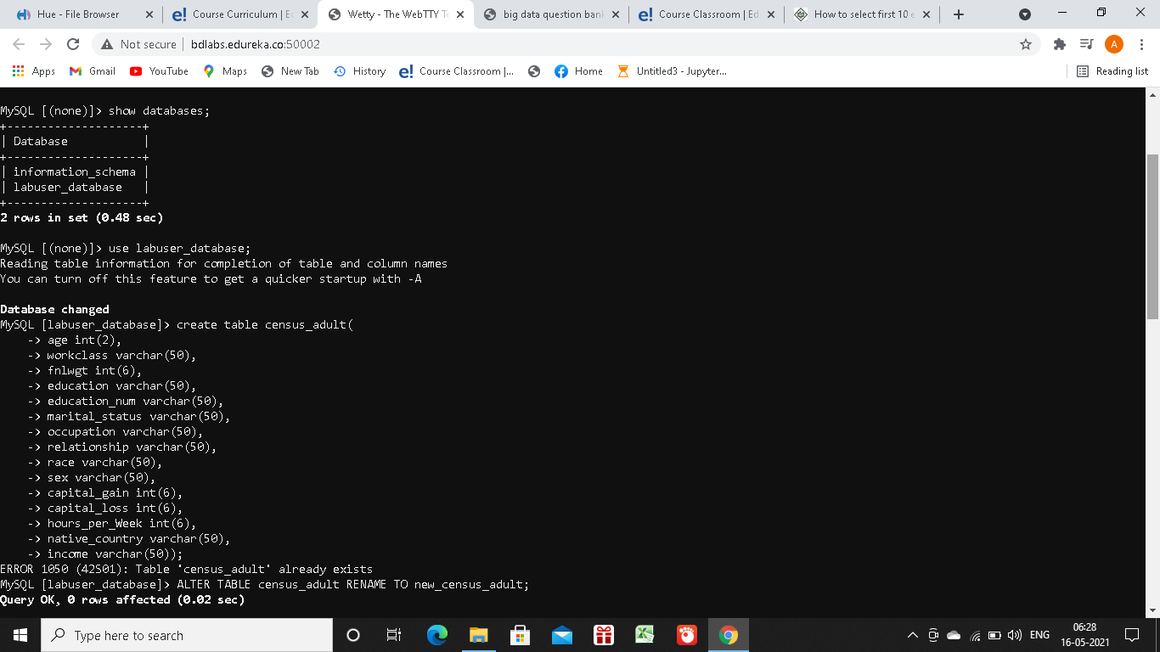

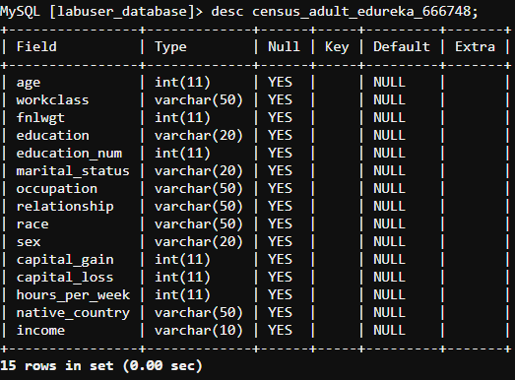

* 1. c. Load the dataset into the table

LOAD DATA LOCAL INFILE '’/home/edureka_/censusdata.csv' INTO TABLE census_adult_edureka_666748 FIELDS TERMINATED BY ',';

* 1. d. Verify whether data is loaded properly
  2. select * from new_census_adult limit 0,5;

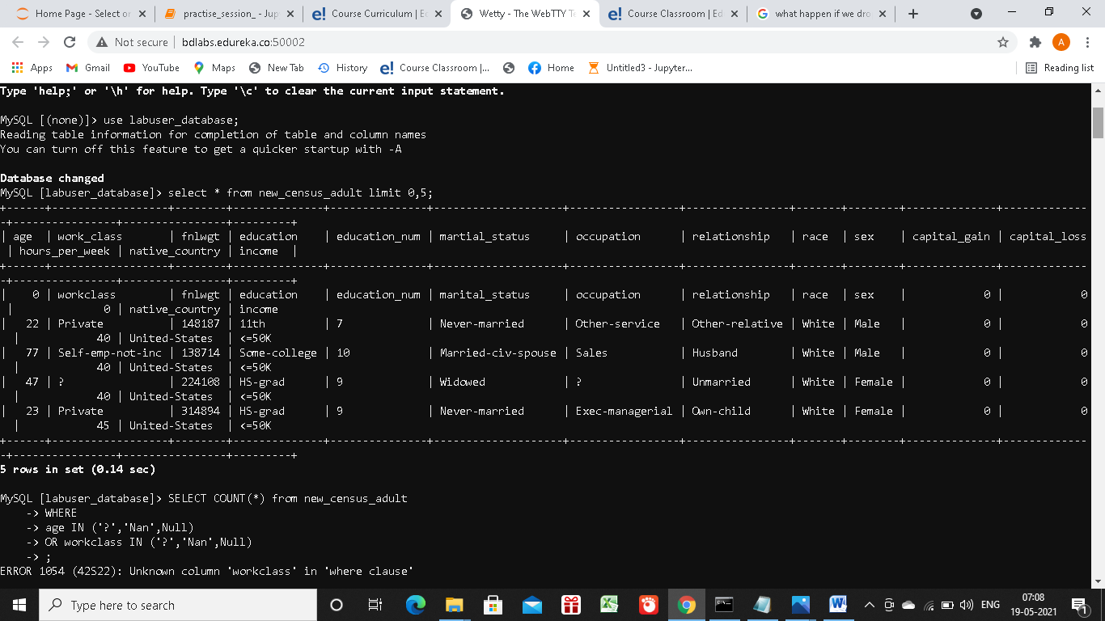

* 1. e. Verify the table for unwanted data such as ‘?’,’Nan’ and ‘Null’

SELECT COUNT(*) from new_census_adult

-> WHERE

-> age IN ('?','Nan','Null')

-> OR work_class IN ('?','Nan','Null')

-> OR fnlwgt IN ('?','Nan','Null')

-> OR education IN ('?','Nan','Null')

-> OR education_num IN ('?','Nan','Null')

-> OR martial_status IN ('?','Nan','Null')

-> OR occupation IN ('?','Nan','Null')

-> OR relationship IN ('?','Nan','Null')

-> OR race IN ('?','Nan','Null')

-> OR sex IN ('?','Nan','Null')

-> OR capital_gain IN ('?','Nan','Null')

-> OR hours_per_week IN ('?','Nan','Null')

-> OR native_country IN ('?','Nan','Null')

-> OR income IN ('?','Nan',Null);

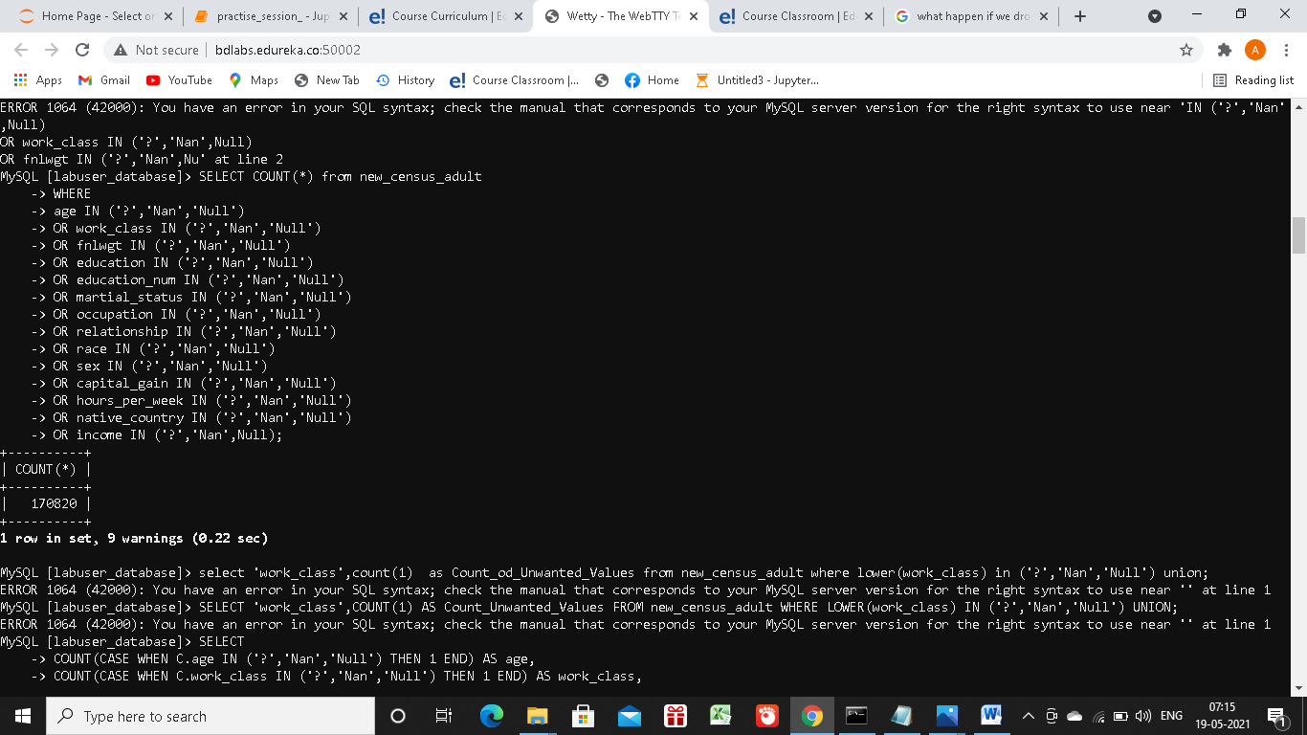

* 1. f. Get the counts for the columns which contain unwanted data

SELECT

-> COUNT(CASE WHEN C.age IN ('?','Nan','Null') THEN 1 END) AS age,

-> COUNT(CASE WHEN C.work_class IN ('?','Nan','Null') THEN 1 END) AS work_class

, -> COUNT(CASE WHEN C.fnlwgt IN ('?','Nan','Null') THEN 1 END) AS fnlwgt,

-> COUNT(CASE WHEN C.education IN ('?','Nan','Null') THEN 1 END) AS education,

-> COUNT(CASE WHEN C.education_num IN ('?','Nan','Null') THEN 1 END) AS education_num,

-> COUNT(CASE WHEN C.martial_status IN ('?','Nan','Null') THEN 1 END) AS martial_status,

-> COUNT(CASE WHEN C.occupation IN ('?','Nan','Null') THEN 1 END) AS occupation,

-> COUNT(CASE WHEN C.relationship IN ('?','Nan','Null') THEN 1 END) AS relationship,

-> COUNT(CASE WHEN C.race IN ('?','Nan','Null') THEN 1 END) AS race,

-> COUNT(CASE WHEN C.sex IN ('?','Nan','Null') THEN 1 END) AS sex,

-> COUNT(CASE WHEN C.capital_gain IN ('?','Nan','Null') AND C.capital_gain !=0 THEN 1 END) AS capital_gain,

-> COUNT(CASE WHEN C.capital_loss IN ('?','Nan','Null') AND C.capital_loss !=0 THEN 1 END) AS capital_loss,

-> COUNT(CASE WHEN C.hours_per_week IN ('?','Nan','Null') THEN 1 END) AS hours_per_week,

-> COUNT(CASE WHEN C.native_country IN ('?','Nan','Null') THEN 1 END) AS native_country,

-> COUNT(CASE WHEN C.income IN ('?','Nan','Null') THEN 1 END) AS income

-> FROM new_census_adult C;

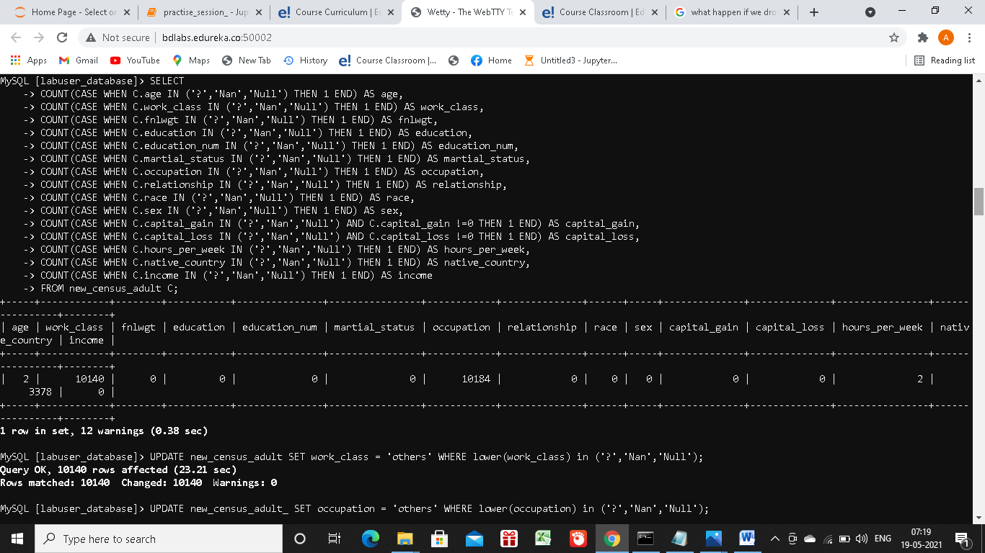

* 1. g. Clean the data by replacing the unwanted data with others

UPDATE new_census_adult SET occupation = 'others' WHERE lower(occupation) in ('?','Nan','Null');

UPDATE new_census_adult SET native_country = 'others' WHERE lower(native_country) in ('?','Nan','Null');

UPDATE new_census_adult SET work_class = 'others' WHERE lower(work_class) in ('?','Nan','Null');

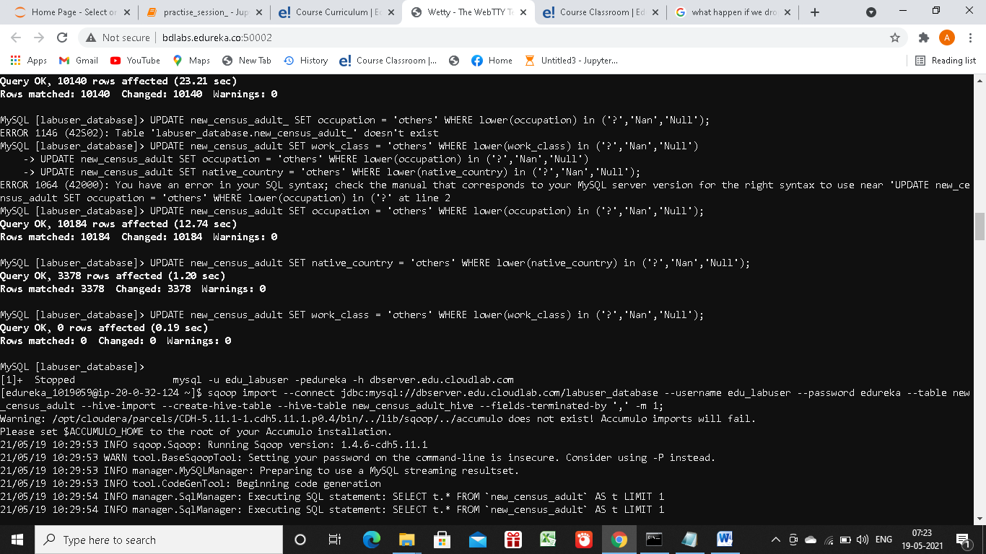

2. Import the above data from MySQL into a Hive table using Sqoop

sqoop import --connect jdbc:mysql://dbserver.edu.cloudlab.com/labuser_database --username edu_labuser --password edureka --table new_census_adult --hive-import --create-hive-table --hive-table new_census_adult_hive --fields-terminated-by ',' -m 1;

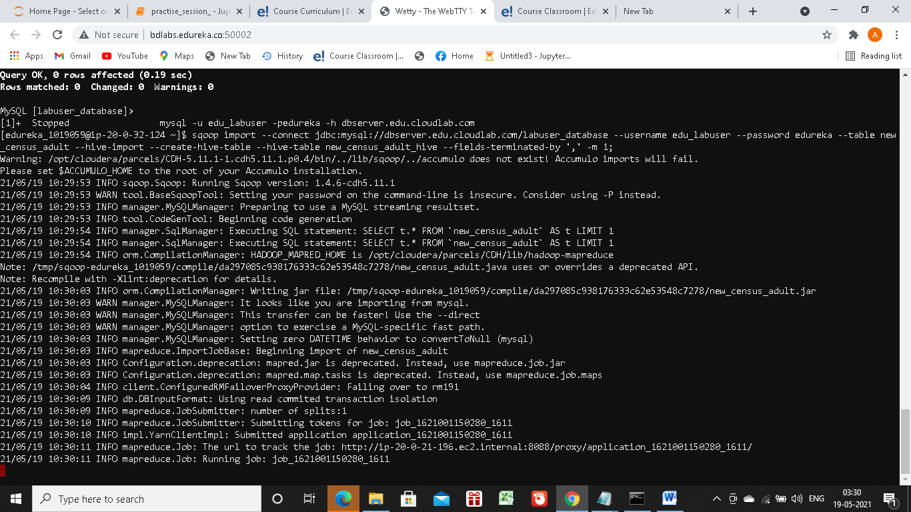

* 1. 3. Connect to PySpark using web console to access the created Hive table. Perform the following queries and note the time taken for execution in each of the queries.
  2. from pyspark.context import SparkContext;
  3. from pyspark.sql import HiveContext;
  4. sqlContext = HiveContext(sc);
  5. census_adult_hive=sqlContext.table('new_census_adult_hive');
  6. census_adult_hive.registerTempTable('census_adult_hive_temp');
  7. 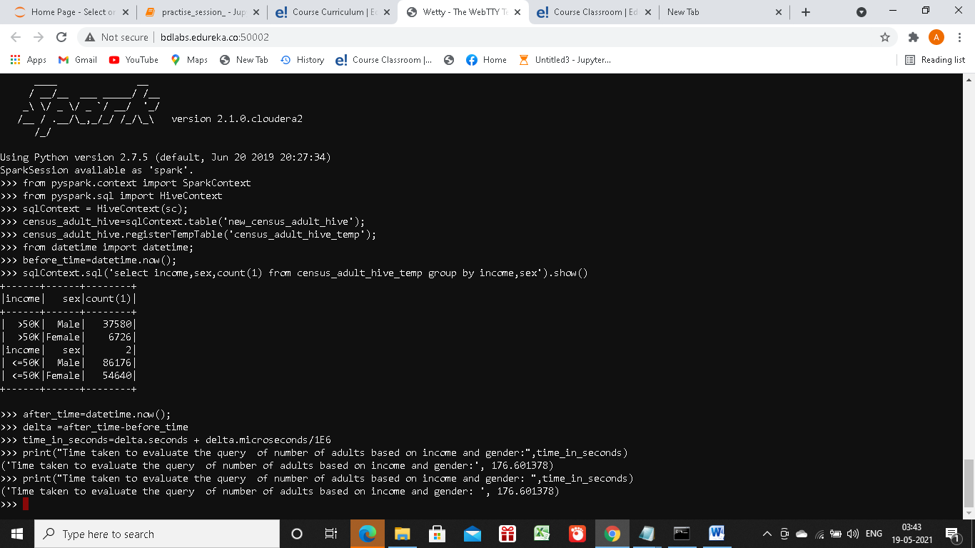
  8. a. Query the table to get the number of adults based on income and gender
  9. from datetime import datetime;
  10. before_time=datetime.now();
      + 1. sqlContext.sql('select income,sex,count(1) from census_adult_hive_temp group by
        2. income,sex').show()
        3. after_time=datetime.now();
        4. delta =after_time-before_time
        5. time_in_seconds=delta.seconds + delta.microseconds/1E6
        6. print("Time taken to evaluate the query of number of adults based on income and
        7. gender:",time_in_seconds)
        8. ('Time taken to evaluate the query of number of adults based on income and gender:',
        9. 176.601378)
  11. 
  12. b. Query the table to get the number of adults based on income and workclass
  13. before_time=datetime.now();
  14. sqlContext.sql('select income,work_class,count(1) from census_adult_hive_temp group
  15. by income,work_class').show();
  16. after_time=datetime.now();
  17. delta =after_time-before_time
  18. time_in_seconds=delta.seconds + delta.microseconds/1E6
  19. print("Time taken to evaluate the query of number of adults based on income and
  20. work_class: ",time_in_seconds)
  21. ('Time taken to evaluate the query of number of adults
  22. based on income and work_class: ', 82.102633)

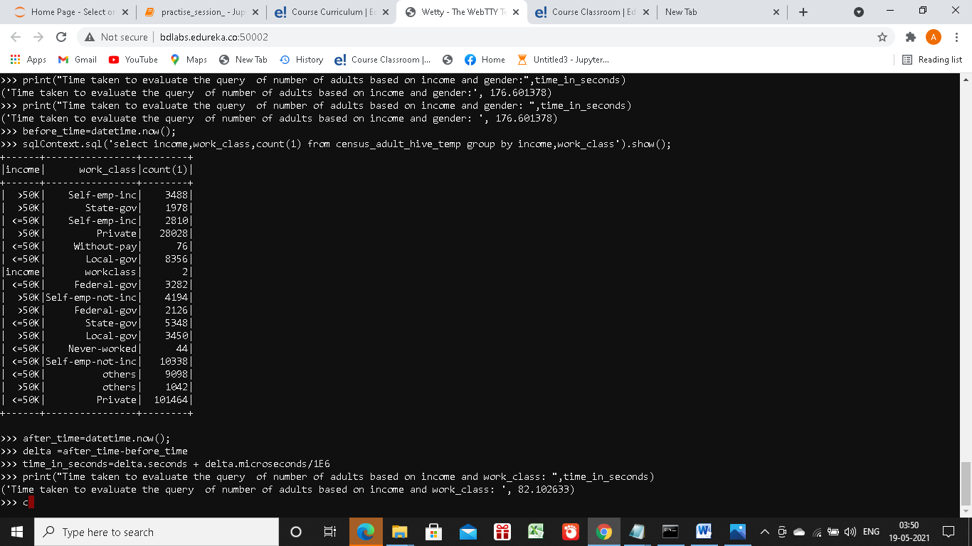

>>pyspark2

>>from pyspark.context import SparkContext

>>from pyspark.sql import HiveContext

>>sqlContext = HiveContext(sc)

4. Access the following two tables created as part of Problem 1 (HDFS and Hive) and perform the steps as mentioned below:

a. Access Hive External Table with partition

censusdata_partitioned_external = sqlContext.table("census1_data_partitioned")

censusdata_partitioned_external.registerTempTable("censusdata_partitioned_external_temp")

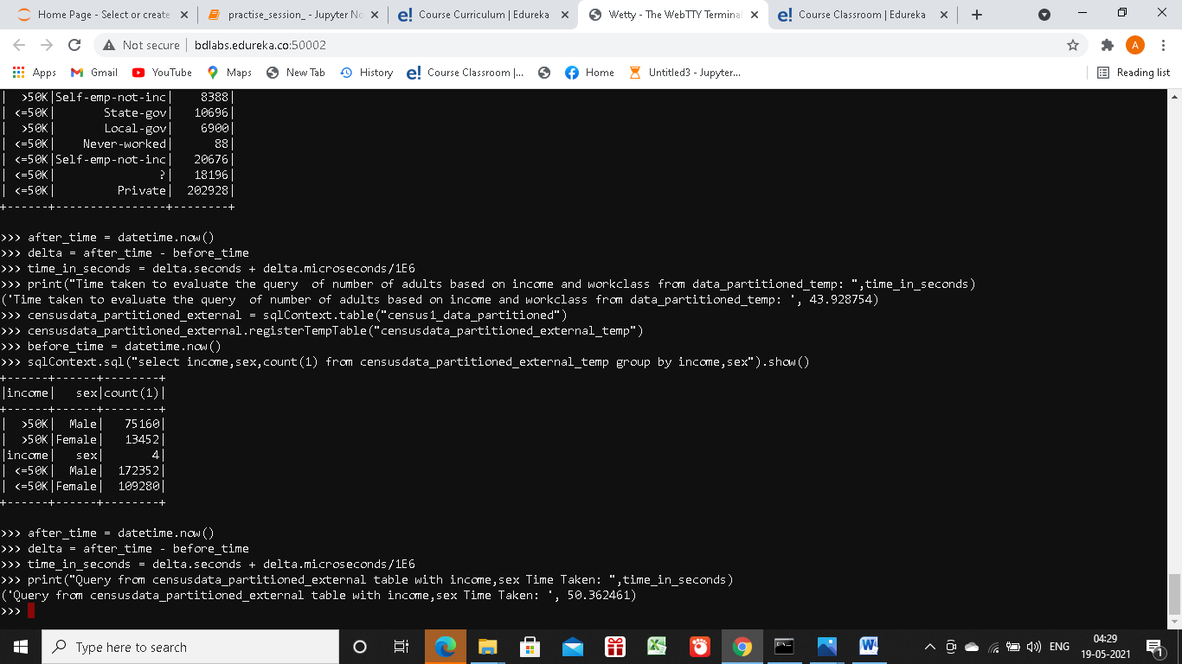

i. Query the table to get the number of adults based on income and gender

before_time = datetime.now()

sqlContext.sql("select income,sex,count(1) from censusdata_partitioned_external_temp group by income,sex").show

after_time = datetime.now()

delta = after_time - before_time

time_in_seconds = delta.seconds + delta.microseconds/1E6 print("censusdata_partitioned_external with income,sex Time Taken: ",time_in_seconds)



ii. Query the table to get the number of adults based on income and workclass

before_time = datetime.now()

sqlContext.sql("select income,workclass,count(1) from censusdata_partitioned_external_temp group by income,workclass").show()

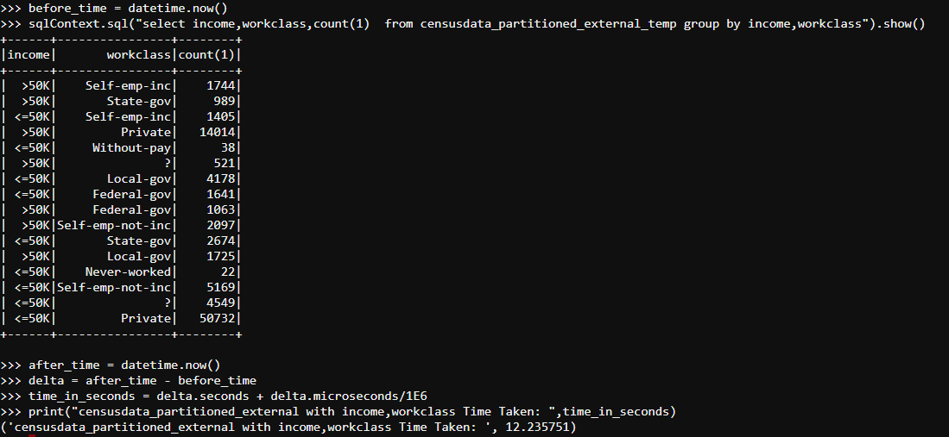

after_time = datetime.now()

delta = after_time - before_time

time_in_seconds = delta.seconds + delta.microseconds/1E6

print("censusdata_partitioned_external with income,workclass Time Taken: ",time_in_seconds)

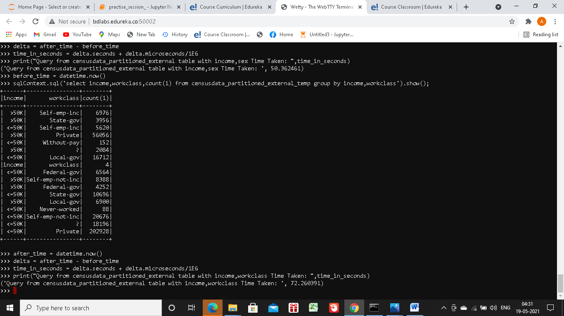

b. Access Hive Internal Table with Partition

data_partitioned=sqlContext.table('census1_data_partitioned')

data_partitioned.registerTempTable('data_partitioned_temp');

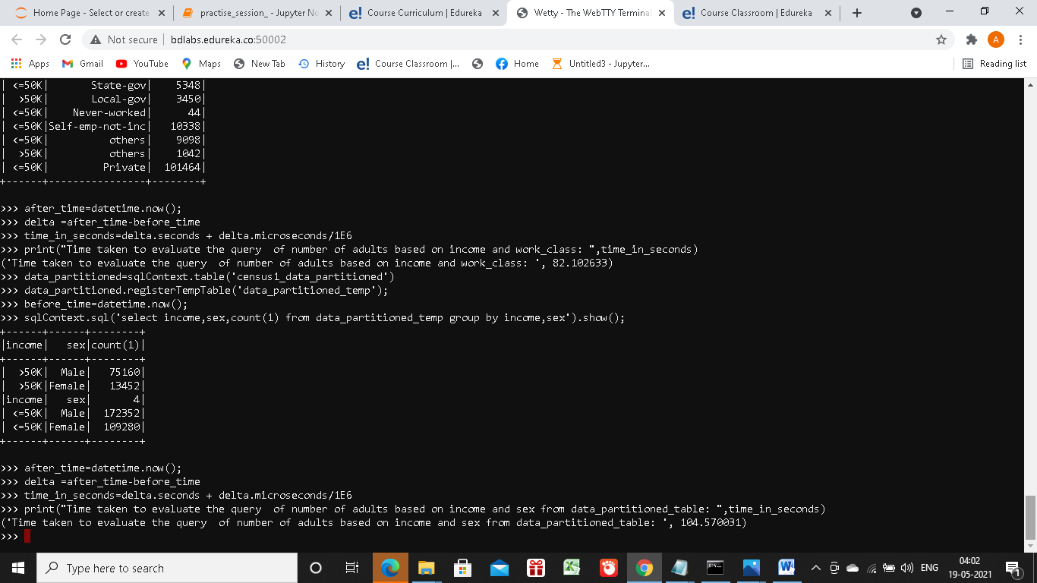

i. Query the table to get the number of adults based on income and gender

before_time = datetime.now()

sqlContext.sql("select income,sex,count(1) data_partitioned_temp group by income,sex").show()

after_time = datetime.now()

delta = after_time - before_time

time_in_seconds = delta.seconds + delta.microseconds/1E6

print("censusdata_partitioned with income,sex Time Taken: ",time_in_seconds)



ii. Query the table to get the number of adults based on income and workclass

before_time = datetime.now()

sqlContext.sql("select income,workclass,count(1) from data_partitioned_temp group by income,workclass").show()

after_time = datetime.now()

delta = after_time - before_time

time_in_seconds = delta.seconds + delta.microseconds/1E6

print("censusdata_partitioned income,workclass Time Taken: ",time_in_seconds)

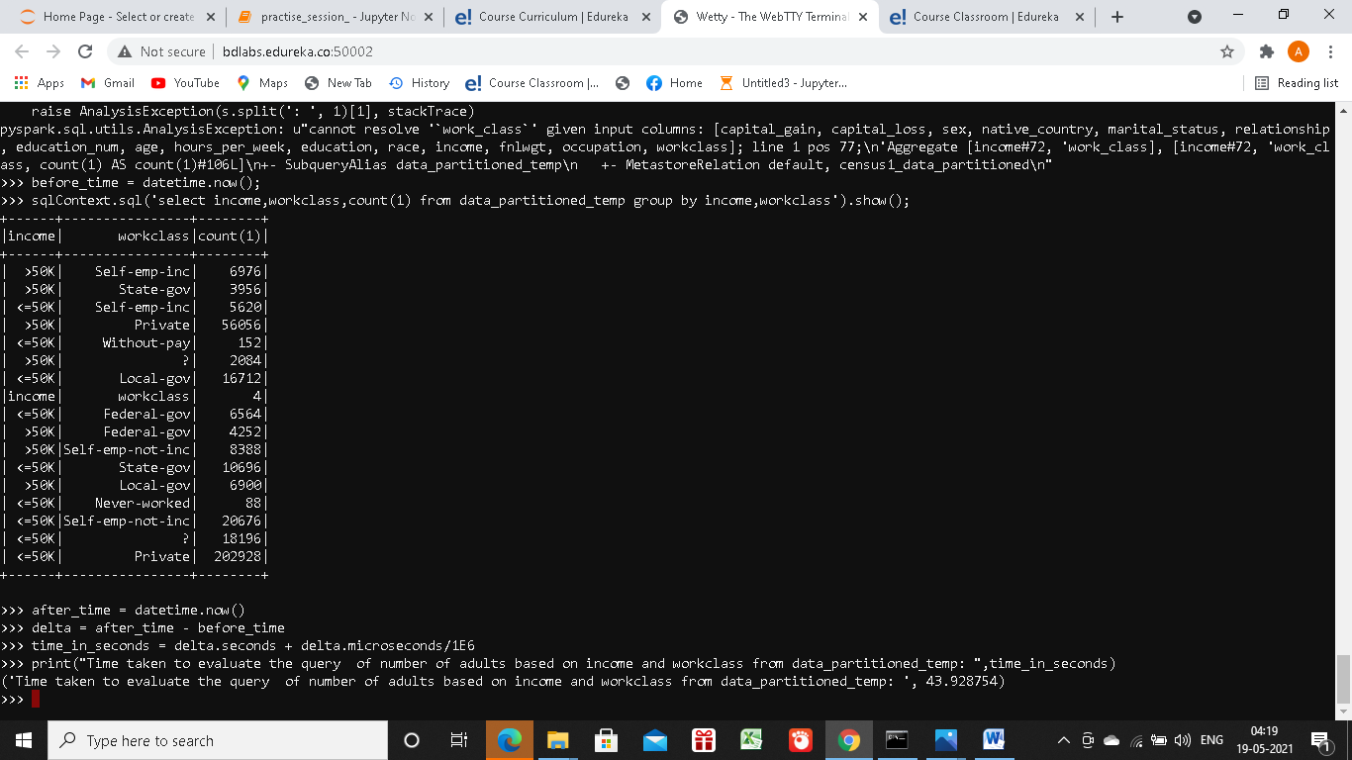

Make a note of the time taken for getting the result in comparison with the time taken to get results with Hive.

|  |  |  |  |
| --- | --- | --- | --- |
| OBSERVATIONS IN BOTH QUERIES WRT TIME TAKEN IN THE 4 TABLES IN SECONDS | | | |
| Query | SQL Table | External Partitioned Table | Internal Partitioned Table |
| Query1 | **176.06** | **50.36** | **104.57** |
| Query2 | **82.03** | **72.26** | **44.00** |

5. Comment on the time taken for executing these commands using Spark as compared to the time taken for execution in Hive (Problem Statement 1).

Comment :

1. When we use Partition column in Query, that reduces query time significantly in case of partitioned tables.

2.Query on Hive tables is faster than sql tables.(Especially when the query is performed on a partition column)